CLASS IX – INFORMATION TECHNOLOGY (402)
Part B – Subject Specific Skills
Unit 3: Digital Documentation
Session 1: Creating a Document Using a Word Processor
Software Used: LibreOffice Writer
Important: The correct name is LibreOffice Writer, not “LibreOffice Write”.

1. Introduction to Digital Documentation
Digital Documentation means creating, editing, formatting, storing and sharing documents in digital form using a computer or other electronic device.
Examples of digital documents:
- Letters
- Applications
- Reports
- Notices
- Resumes
- School assignments
- Question papers
- Business documents
A word processor is one of the most commonly used applications for creating digital documents.
LibreOffice Writer
LibreOffice Writer is a free and open-source word processing application included in the LibreOffice office suite.
It can be used to:
- Create documents
- Type and edit text
- Format text and paragraphs
- Insert images and shapes
- Create tables
- Check spelling and grammar
- Add headers and footers
- Create columns
- Save and print documents

2. What is a Word Processor?
A Word Processor is a software application used to create, edit, format, save, print and manage text-based documents.
Examples of Word Processors
- LibreOffice Writer
- Microsoft Word
- Google Docs
- WPS Writer
- Apple Pages
Example
If you want to prepare a school application, instead of writing it manually on paper, you can type it in LibreOffice Writer, format it, save it and print it.

3. Features and Applications of Word Processors
Word processors provide many features that make document creation easier and faster.
3.1 Fast
A word processor allows us to type and create documents quickly.
Example:
A long letter can be typed, edited and formatted much faster than writing it by hand.

3.2 Editing Features
Text can easily be modified after typing.
We can:
- Add text
- Delete text
- Move text
- Copy text
- Paste text
- Undo changes
- Redo changes
- Find text
- Replace text
Example:
If you make a spelling mistake, you can correct it without rewriting the entire document.

3.3 Permanent Storage
Documents can be saved on:
- Computer hard disk/SSD
- Pen drive
- External storage
- Cloud storage
A saved document can be opened and used later.
Example:
A school report created today can be saved and edited next month.

3.4 Formatting
Formatting changes the appearance of text and documents.
We can change:
- Font type
- Font size
- Font colour
- Font style
- Alignment
- Line spacing
- Paragraph indentation
- Page orientation
- Margins
Example:
Computer Education
can be formatted using a different font, size and colour.

3.5 Graphics
Word processors allow us to insert graphical objects such as:
- Pictures
- Shapes
- Diagrams
- Charts
- Logos
Graphics make documents more attractive and easier to understand.

3.6 OLE – Object Linking and Embedding
OLE stands for Object Linking and Embedding.
It is a technology that allows an object created in one application to be inserted into another application.
For example, a spreadsheet or chart created in a spreadsheet program can be inserted into a Writer document.
Linking vs Embedding
Linking | Embedding
The inserted object remains connected to the original file. | A copy of the object is placed inside the document.
Changes in the original object can be reflected in the document. | Changes to the original file normally do not automatically change the embedded object.
Requires access to the source file. | Object becomes part of the document.

3.7 Spell Check
A word processor can identify many spelling mistakes.
For example:
Computar ❌
Computer ✅
LibreOffice Writer can also provide grammar checking depending on the installed language tools.
Note: Spell checking does not guarantee that every sentence is grammatically or factually correct.

3.8 Mail Merge
Mail Merge is a feature used to create multiple documents with the same main content but different personal information.
For example, a school can create invitation letters for 100 students using one common letter and a list containing:
- Student Name
- Class
- Roll Number
- Address
Instead of typing 100 letters separately, Mail Merge can automatically generate personalized letters.
Common applications
- Invitation letters
- Certificates
- Address labels
- Circulars
- Notices
- Business letters

4. Working with LibreOffice Writer
The basic process of creating a document is:
Create/Open → Type → Edit → Format → Save → Close
Step 1: Create or Open a Document
Create a new document or open an existing document.
Step 2: Type Text
Enter the required text using the keyboard.
Step 3: Edit the Document
Correct mistakes and modify the content if required.
Step 4: Format the Document
Apply suitable formatting such as:
- Bold
- Italic
- Font size
- Alignment
- Paragraph spacing
- Headings
Step 5: Save the Document
Save the document so that it can be used later.
Step 6: Close the Document
After completing the work, close the document.

5. Major Components of the Writer Document Window
The LibreOffice Writer window contains several important components.
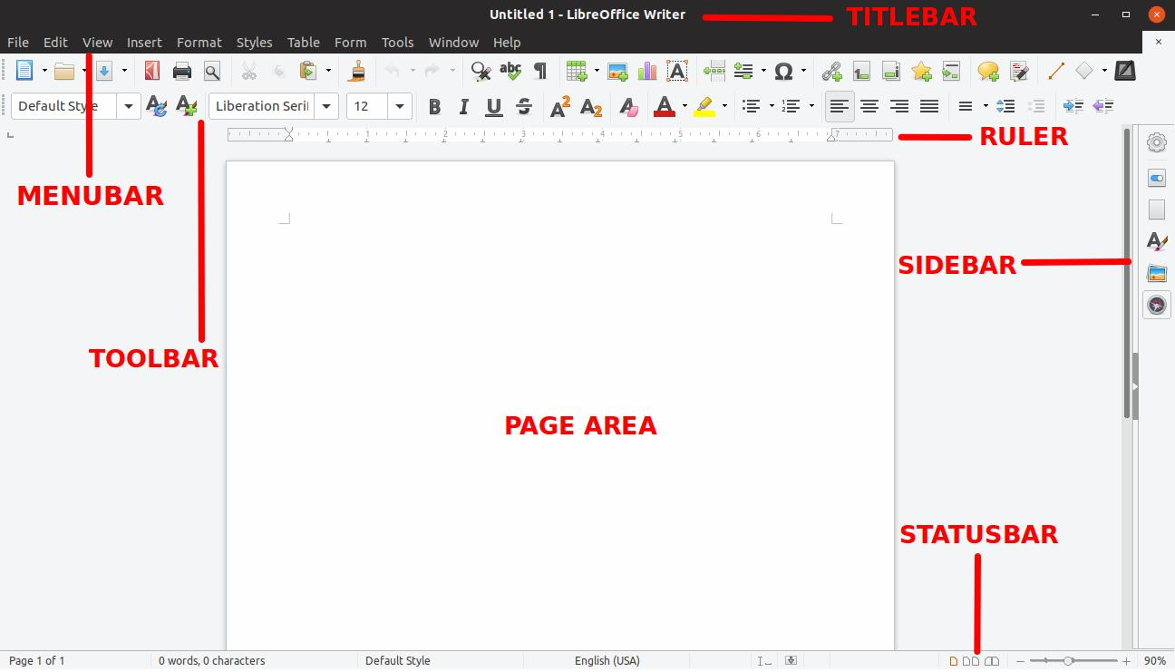
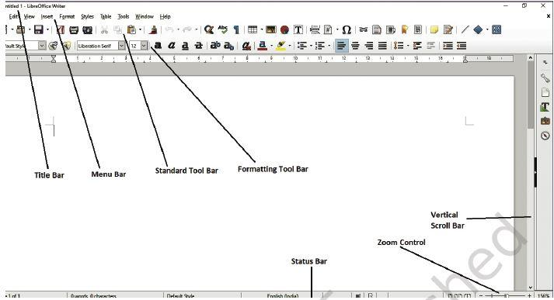
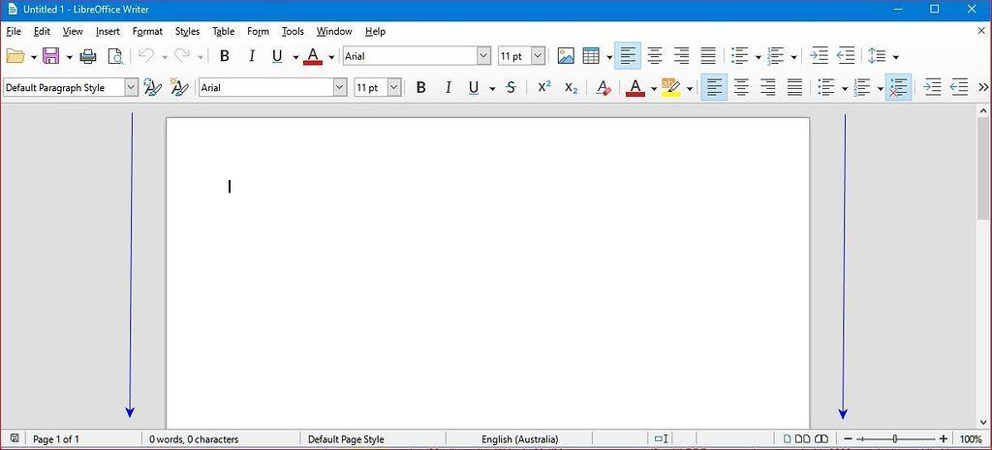
5
5.1 Title Bar
The Title Bar appears at the top of the window.
It displays:
- Name of the current document
- LibreOffice Writer application name
For a new unsaved document, a temporary name such as Untitled 1 may be displayed.

5.2 Menu Bar
The Menu Bar contains menus that provide commands and functions.
Common menus include:
- File
- Edit
- View
- Insert
- Format
- Styles
- Table
- Form
- Tools
- Window
- Help

5.3 Standard Toolbar
The Standard Toolbar contains commonly used commands such as:
- New
- Open
- Save
- Print
- Undo
- Redo
- Cut
- Copy
- Paste
It provides quick access to frequently used commands.

5.4 Formatting Bar
The Formatting Bar contains tools used to format text.
Common options include:
- Font name
- Font size
- Bold
- Italic
- Underline
- Font colour
- Text highlighting
- Alignment
- Line spacing

5.5 Ruler
The Ruler helps us:
- Set margins
- Set tab stops
- Set paragraph indents
- Position text accurately
Writer normally provides horizontal and vertical rulers depending on the view/settings.

5.6 Status Bar
The Status Bar is located at the bottom of the document window.
It provides information about the document, such as:
- Current page
- Number of pages
- Word count
- Language
- View information
- Zoom level

5.7 Scroll Bar
Scroll bars allow us to move through the document.
- Vertical scroll bar – moves up and down.
- Horizontal scroll bar – moves left and right when required.

5.8 Work Area / Text Area
The Work Area is the main area where we type and edit the document.
It is sometimes called the document area or text area.

5.9 Zoom Slider
The Zoom Slider is generally located on the status bar.
It allows us to increase or decrease the size at which the document is displayed on the screen.
Important: Zoom changes the display size, not the actual font size of the document.

6. Document Views
LibreOffice Writer provides different ways to view a document.
6.1 Normal / Print Layout View
This is the normal working view used for creating and editing documents.
It displays the document approximately as it will appear when printed.
Used for:
Writing, editing and formatting documents.

6.2 Web View
Web View displays the document in a way suitable for viewing as a web page.
It is useful when the document is intended for web-based presentation.

6.3 Full Screen View
Full Screen View displays the document using most or all of the available screen area, reducing interface elements.
It is useful when you want to concentrate on the document or get a larger working area.

7. Starting LibreOffice Writer
LibreOffice Writer can be started from the operating system's application menu.
A typical method is:
Applications/Menu → LibreOffice → LibreOffice Writer
The exact steps may differ depending on the operating system and LibreOffice installation.

8. Creating a New Document
A new Writer document can be created using:
File → New → Text Document
Keyboard Shortcut
Ctrl + N
Ctrl + N creates a new document.

9. Text Area
The Text Area is the main area where the user enters text.
When the cursor is visible in the text area, we can start typing using the keyboard.
The blinking vertical line is called the insertion point or text cursor.
It indicates where the next character will appear.

10. Word Wrap
Word Wrap is a feature that automatically moves a word to the next line when there is not enough space remaining on the current line.
Example
Suppose a sentence reaches the right margin:
Information Technology is an important
The next word may automatically move to the next line.
We do not need to press Enter at the end of every line.
Important
Press Enter only when you want to start a new paragraph or line intentionally.

11. Enter Key
The Enter key is generally used to:
- Start a new paragraph
- Move the cursor to the next paragraph
- Create a new paragraph
Example
My name is Rahul.

I study in Class IX.
Pressing Enter after the first sentence creates a new paragraph.
Remember
Word Wrap: Automatically moves text to the next line.
Enter: Creates a new paragraph.

12. Opening an Existing Document
To open an existing Writer document:
File → Open
or use the keyboard shortcut:
Ctrl + O
Then:
- Select the required file.
- Click Open.

13. Saving a Document
Saving stores the document for future use.
Use:
File → Save
or:
Ctrl + S
If the document is being saved for the first time, Writer asks for:
- File name
- Location/folder
- File type/format
Then click Save.

14. ODT – OpenDocument Text Format
By default, a new LibreOffice Writer document is saved in the OpenDocument Text format.
File Extension
.odt
ODT stands for OpenDocument Text.
Example:
MyAssignment.odt
Important
- .odt → OpenDocument Text
- It is the standard text-document format used by LibreOffice Writer.
- Other formats such as .docx can also be opened and saved when required.

15. Closing a Document
After completing the work, we can close the current document.
Use:
File → Close
or click the Close button of the document window.
Important
Closing a document is different from exiting LibreOffice.
- Close: Closes the current document.
- Exit: Closes the LibreOffice application.
If there are unsaved changes, Writer may ask whether you want to Save, Discard, or Cancel.

16. Exiting LibreOffice Writer
To completely close LibreOffice Writer, use:
File → Exit LibreOffice
or the appropriate application close option.
Remember:
Close Document ≠ Exit Writer

17. Word Processing Terminology
Understanding common terminology is important when working with word processors.

17.1 Margin
A margin is the blank space between the edge of a page and the document's content.
There are generally four page margins:
- Top margin
- Bottom margin
- Left margin
- Right margin
Example
|← Margin →| Document Text
Margins help keep text away from the edges of the page.

18. Columns
Columns divide the page into two or more vertical sections.
For example:
| Column 1 | Column 2 |
|----------|----------|
| Text | Text |
| Text | Text |
Columns are commonly used in:
- Newspapers
- Magazines
- Newsletters
- Brochures

19. Word Wrapping
Word wrapping is the automatic movement of text to the next line when the current line reaches the margin.
Key Point
We don't need to press Enter after every line.

20. Indentation
Indentation is the amount by which a paragraph is moved inward from the page margin.
Types of paragraph indentation include:
- Left indent
- Right indent
- First-line indent
- Hanging indent
Example
Normal paragraph:
This is a paragraph.
Indented paragraph:
This is an indented paragraph.

21. Paragraph Indentation vs Page Margins
These two concepts are often confused.
Page Margins | Paragraph Indentation
Define the boundary of the page content area. | Changes the position of a particular paragraph.
Usually applies to the page/page style. | Applies to selected paragraph(s).
Includes top, bottom, left and right margins. | Includes left, right, first-line and hanging indentation.
Creates space between page edge and content. | Moves paragraph text inward or changes its first line position.
Simple Example
Margin:
Controls where the document's content area begins.
Indentation:
Controls where a particular paragraph begins within that content area.

22. Font Style and Font Size
Font
A font is the design/style of characters used in a document.
Examples:
- Liberation Serif
- Liberation Sans
- Carlito
- DejaVu Sans
Font Size
Font size determines the relative size of characters.
Examples:
- 10 pt
- 12 pt
- 14 pt
- 16 pt
- 20 pt
Example
12 pt: Computer
20 pt: Computer

23. Text Attributes
Text attributes are formatting characteristics applied to text.
Common text attributes include:
Bold
Makes text darker/thicker.
Example: Computer
Shortcut: Ctrl + B
Italic
Makes text slanted.
Example: Computer
Shortcut: Ctrl + I
Underline
Adds a line below text.
Example: <u>Computer</u>
Shortcut: Ctrl + U
Other text attributes include:
- Font colour
- Highlighting
- Superscript
- Subscript
- Strikethrough
- Font size
- Font type

24. Text Alignment
Alignment determines the position of text within the available space.
The four common horizontal alignments are:
Alignment | Description | Common Shortcut
Left | Text starts from the left margin. | Ctrl + L
Center | Text is placed in the centre. | Ctrl + E
Right | Text ends at the right margin. | Ctrl + R
Justified | Text is aligned with both left and right margins. | Ctrl + J
Example
Left Alignment
Computer Education
is important.
Center Alignment
Computer Education
is important.
Right Alignment
Computer Education
is important.
Justified Alignment
Text is distributed so that both left and right edges are aligned, except where the final line does not require full justification.

25. Horizontal and Vertical Alignment
Horizontal Alignment
Controls the position of text from left to right.
Examples:
- Left
- Center
- Right
- Justified
Vertical Alignment
Controls the position of content from top to bottom within a page or container.
Examples:
- Top
- Center
- Bottom
Note: In normal Writer paragraphs, horizontal alignment is used much more frequently. Vertical alignment is particularly useful for page layouts, tables, frames and other objects.

26. Line Spacing
Line spacing is the amount of vertical space between lines of text in a paragraph.
Common options include:
- Single
- 1.15
- 1.5
- Double
Example
Single spacing:
This is the first line.
This is the second line.
Double spacing:
This is the first line.

This is the second line.
Line spacing can improve the readability of a document.

27. Page Orientation
Page orientation determines whether a page is arranged vertically or horizontally.
There are two main orientations:
Portrait
The page is taller than it is wide.
┌─────────┐
│ │
│ Portrait│
│ │
│ │
└─────────┘
Commonly used for:
- Letters
- Applications
- Reports
- School assignments
Landscape
The page is wider than it is tall.
┌─────────────────┐
│ Landscape │
└─────────────────┘
Commonly used for:
- Wide tables
- Charts
- Presentations
- Wide documents

28. Headers and Footers
Header
A header is an area at the top of a page where information can be placed.
Examples:
- School name
- Document title
- Chapter name
- Logo
Footer
A footer is an area at the bottom of a page.
Examples:
- Page number
- Date
- Author name
- Copyright information
Simple Representation
┌─────────────────────────┐
│ HEADER │
├─────────────────────────┤
│ │
│ DOCUMENT BODY │
│ │
├─────────────────────────┤
│ FOOTER │
└─────────────────────────┘
Headers and footers are particularly useful for documents containing multiple pages.

29. Important Keyboard Shortcuts
Shortcut | Function
Ctrl + N | Create a new document
Ctrl + O | Open an existing document
Ctrl + S | Save the document
Ctrl + B | Bold
Ctrl + I | Italic
Ctrl + U | Underline
Ctrl + L | Left align
Ctrl + E | Center align
Ctrl + R | Right align
Ctrl + J | Justify

30. Quick Revision
Remember these important points:
- LibreOffice Writer is a word processing application.
- A word processor is software used to create, edit, format, save and print documents.
- The default LibreOffice Writer document format is ODT.
- .odt means OpenDocument Text.
- Ctrl + N → New document.
- Ctrl + O → Open document.
- Ctrl + S → Save document.
- Word Wrap automatically moves text to the next line.
- Enter is used to start a new paragraph.
- Margins define the space between the page edge and content area.
- Indentation changes the position of a paragraph within the content area.
- Portrait is vertical page orientation.
- Landscape is horizontal page orientation.
- Header appears at the top of a page.
- Footer appears at the bottom of a page.
- OLE stands for Object Linking and Embedding.
- Mail Merge creates multiple personalized documents from common content and data.
- Zoom changes the document's display size, not the actual font size.
- Close closes the current document.
- Exit closes the LibreOffice application.

31. Key Terms – One-Line Definitions
Term | Definition
Word Processor | Software used to create and manage text documents.
LibreOffice Writer | Free and open-source word processing software.
Digital Documentation | Creating and managing documents electronically.
Word Wrap | Automatic movement of text to the next line.
Margin | Blank space between the page edge and content.
Indentation | Moving paragraph text inward from the margin.
Font | Design/style of characters.
Font Size | Size of characters in a document.
Text Attribute | A characteristic used to change text appearance.
Alignment | Positioning of text within the available space.
Line Spacing | Space between lines of text.
Page Orientation | Direction in which a page is arranged.
Header | Area at the top of a page.
Footer | Area at the bottom of a page.
OLE | Object Linking and Embedding.
Mail Merge | Creation of multiple personalized documents using common content and data.
ODT | OpenDocument Text file format.
Zoom | Changes the on-screen display size of a document.

📝 Exam-Oriented Questions
Very Short Answer Questions
- What is a word processor?
- Name any two word processors.
- What is the default file extension of LibreOffice Writer?
- What is Word Wrap?
- What is OLE?
- What is Mail Merge?
- What is a margin?
- What is indentation?
- What is a header?
- What is a footer?
Short Answer Questions
- Explain any four features of a word processor.
- Differentiate between page margins and paragraph indentation.
- Explain the difference between Word Wrap and the Enter key.
- What is Mail Merge? Give two applications.
- Explain the difference between Portrait and Landscape orientation.
- What is the difference between a header and a footer?
- Explain the four types of horizontal text alignment.
- What is OLE? Differentiate between linking and embedding.
Practical Questions
- Create a new Writer document.
- Type a paragraph and save it as an .odt file.
- Open an existing Writer document.
- Apply bold, italic and underline formatting.
- Change the font and font size of a paragraph.
- Apply left, centre, right and justified alignment.
- Change the page orientation from Portrait to Landscape.
- Insert a header and footer.
- Change the line spacing of a paragraph.
- Close the document and exit LibreOffice Writer.

⭐ Easy Flow to Remember
Create → Type → Edit → Format → Save → Close
This is the basic workflow for creating a document using a word processor.

